TASK 3
BI Dashboards — Power BI & Tableau
iNeuBytes VIIP — Data Analyst Internship

Intern Name | Devpal Singh Anand
Regd No | INBT019627
Course ID | DAINB20626
Education | BCA · MCA Cyber Security
Dataset | Olist Brazilian E-Commerce (olist.db)

1. Project Objectives
Build interactive BI dashboards in BOTH Power BI and Tableau using the Olist dataset.
- Power BI (.pbix) — uploaded to GitHub
- Tableau (.twbx) — uploaded to GitHub
2. Data Pre-Processing (ETL)
- Extract: Loaded order_master.csv from olist.db
- Transform: Handled missing values, standardized text, converted dates
- Load: Imported cleaned data into both BI tools
3. Data Modelling & Calculated Metrics
DAX Measures (Power BI):
Measure | DAX Formula
Total Revenue | SUM(order_items[price])
Total Orders | DISTINCTCOUNT(orders[order_id])
Avg Order Value | [Total Revenue] / [Total Orders]
On-Time % | COUNTROWS(FILTER(orders, [status]="On Time")) / COUNTROWS(orders)
Avg Review | AVERAGE(order_reviews[review_score])

Tableau Calculated Fields:
Field | Formula
Revenue Tier | IF SUM([price]) >= 300 THEN 'High' ELSEIF >= 100 THEN 'Mid' ELSE 'Low' END
Delivery Status | IF [delivered] <= [estimated] THEN 'On Time' ELSE 'Late' END

4. Power BI Dashboard
Power BI dashboard contains: KPI card, 3 slicers, shape map, combo chart, clustered bar/column charts, line chart.
4.1 Power BI — Before
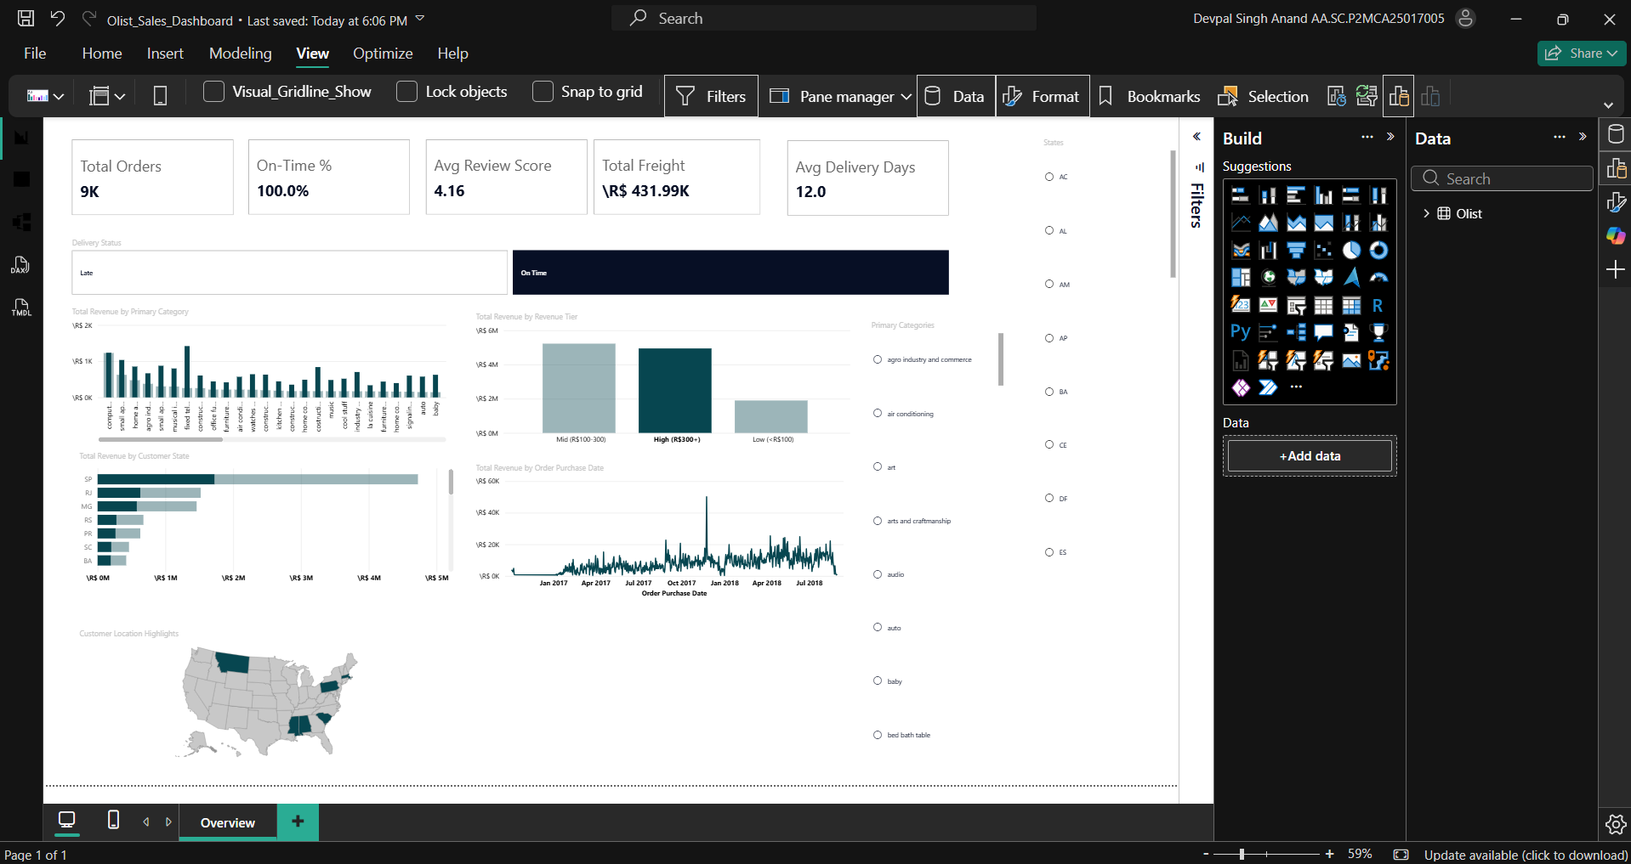
📸 Power BI — Before (default visual)
4.2 Power BI — After
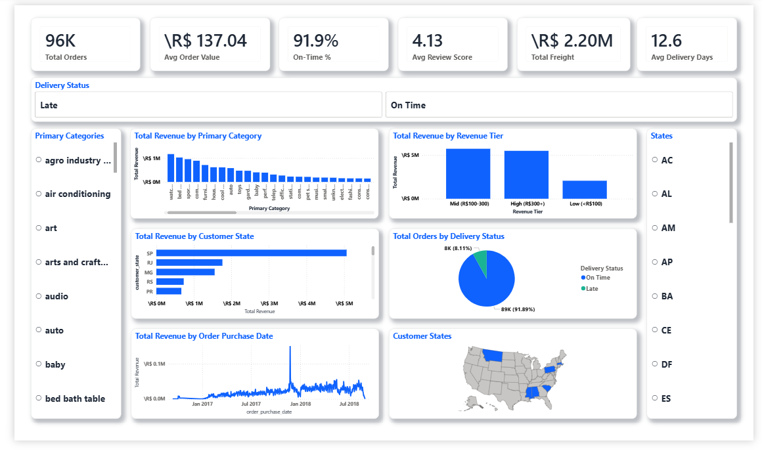
📸 Power BI — After (polished dashboard)
5. Tableau Dashboard
Tableau workbook has 7 worksheets organized into 2 dashboards.
5.1 Tableau Worksheets
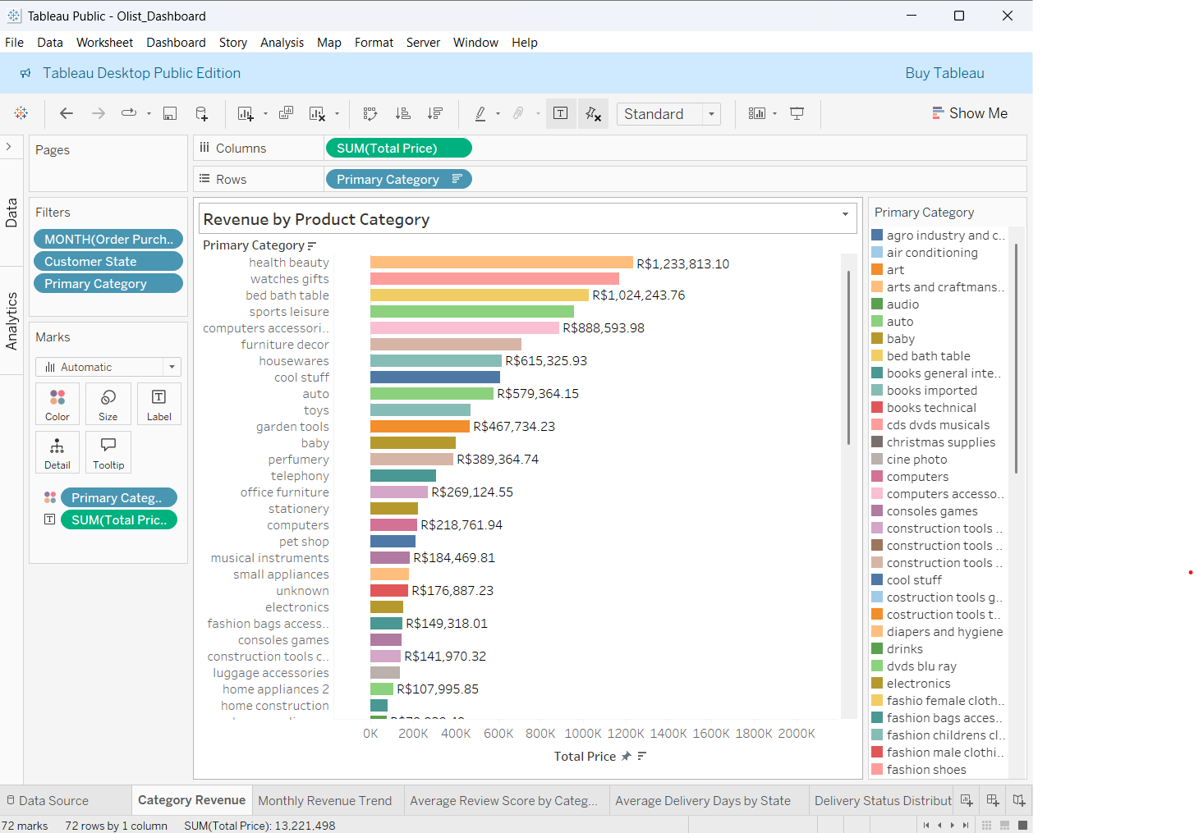
📸 Tableau — Category Revenue
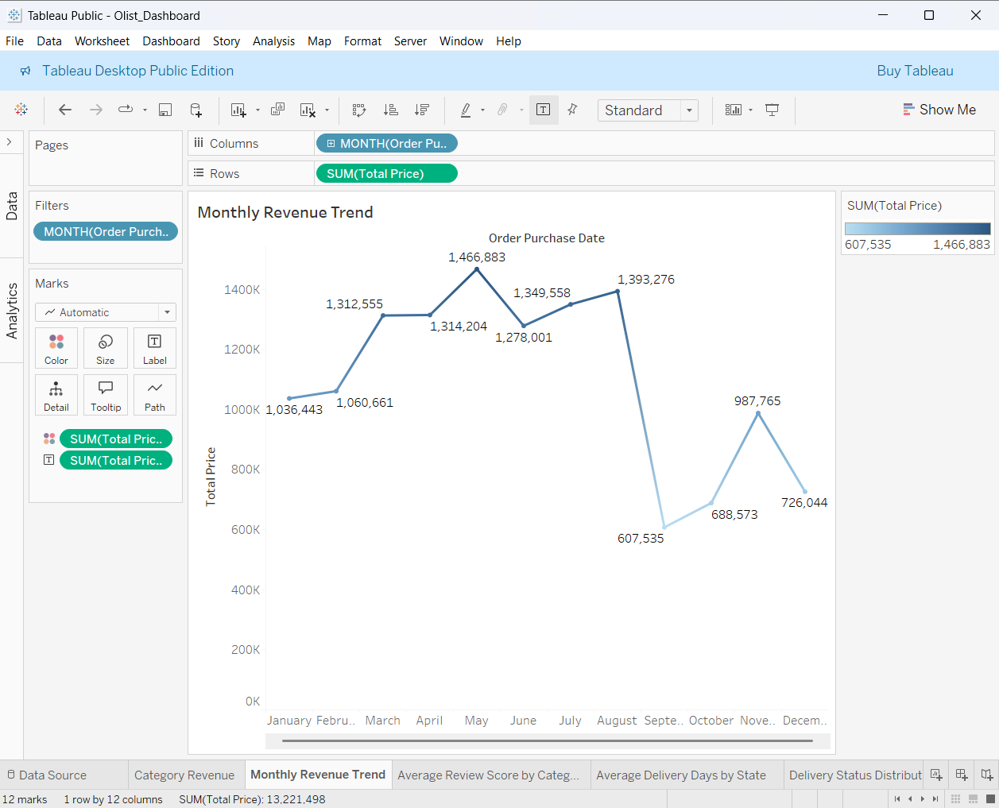
📸 Tableau — Monthly Revenue Trend
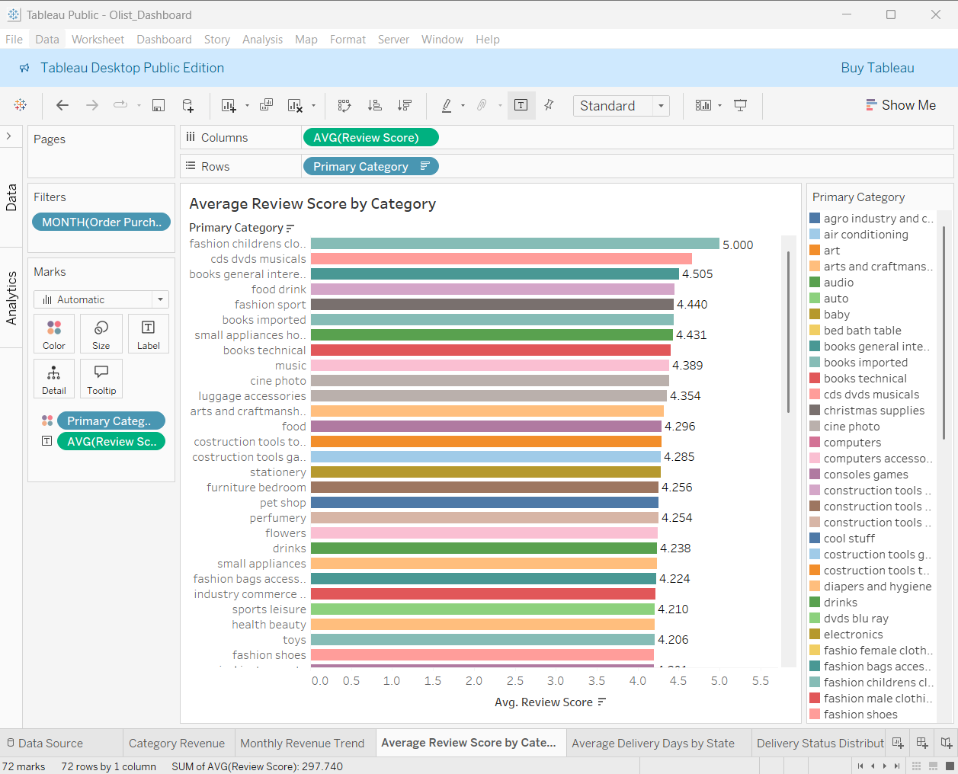
📸 Tableau — Average Review Score by Category
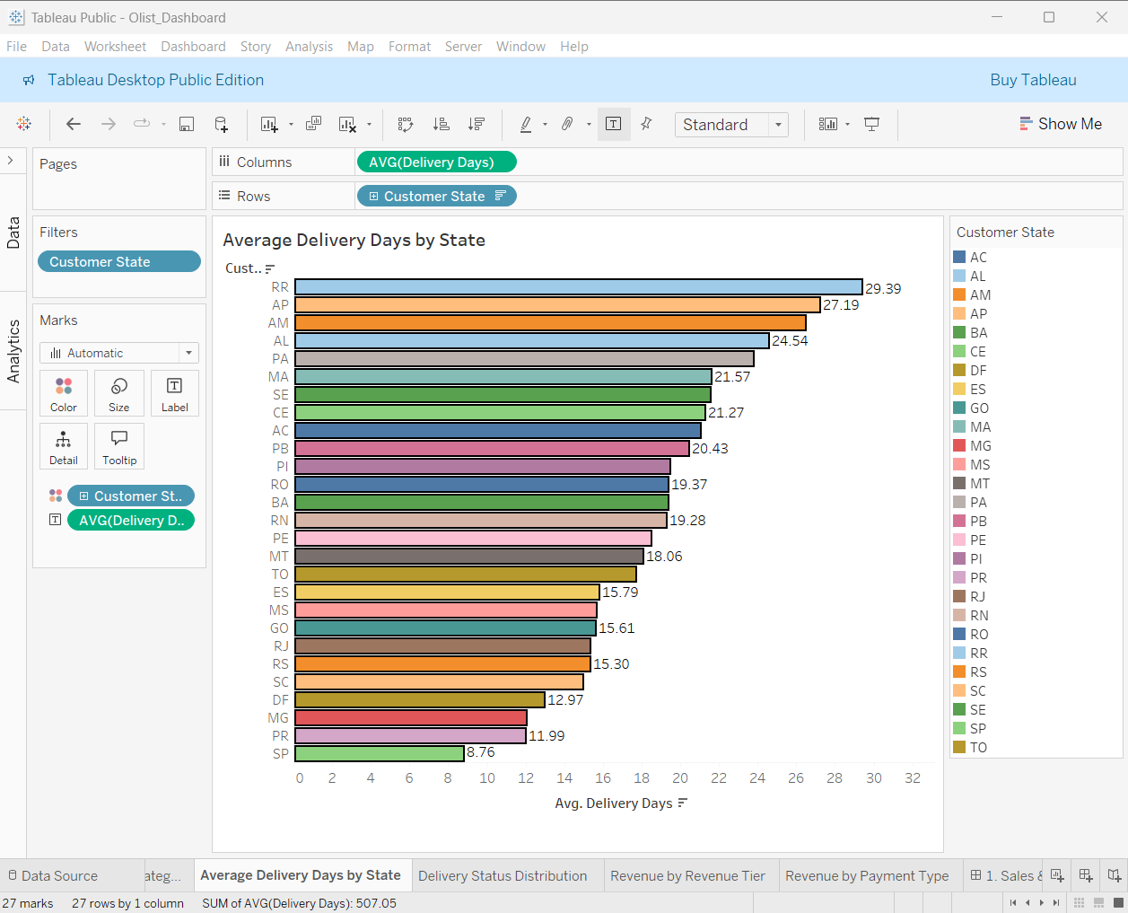
📸 Tableau — Average Delivery Days by State
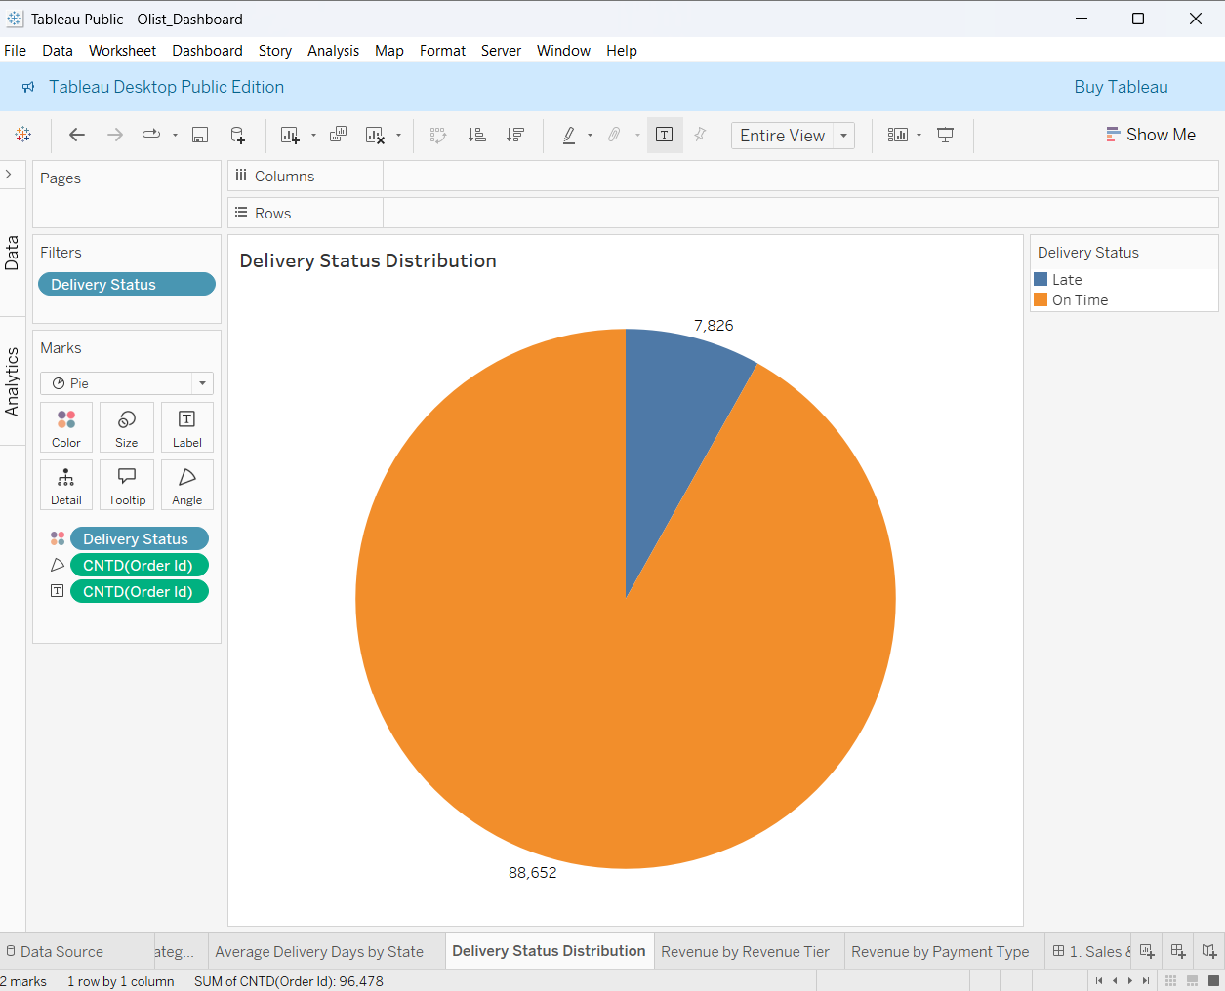
📸 Tableau — Delivery Status Distribution
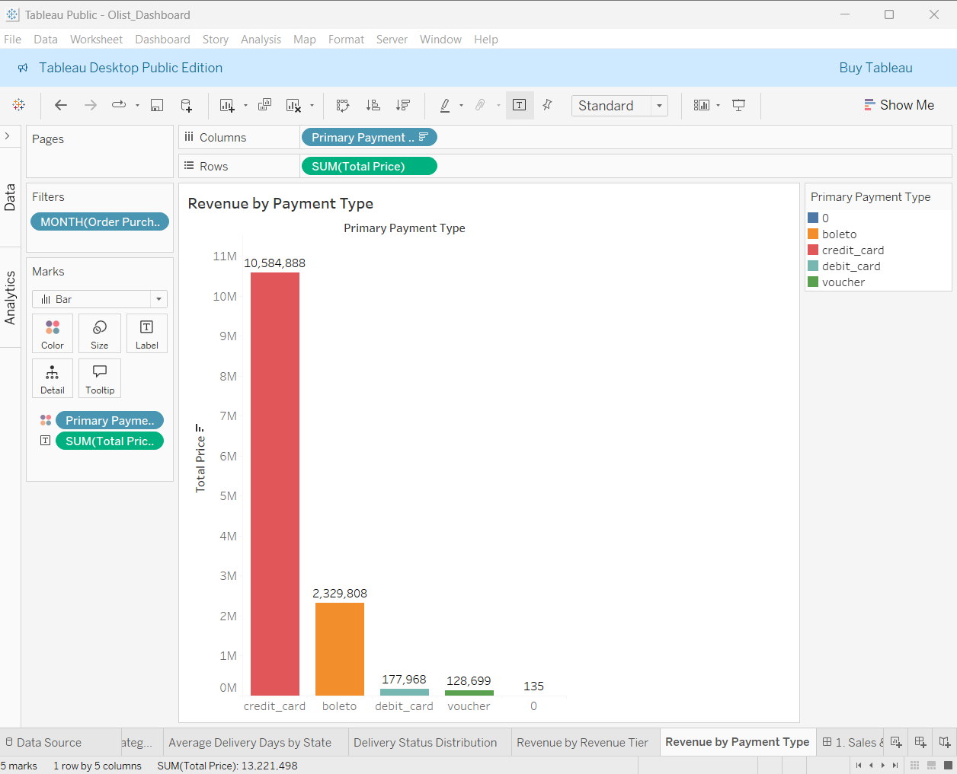
📸 Tableau — Revenue by Payment Type
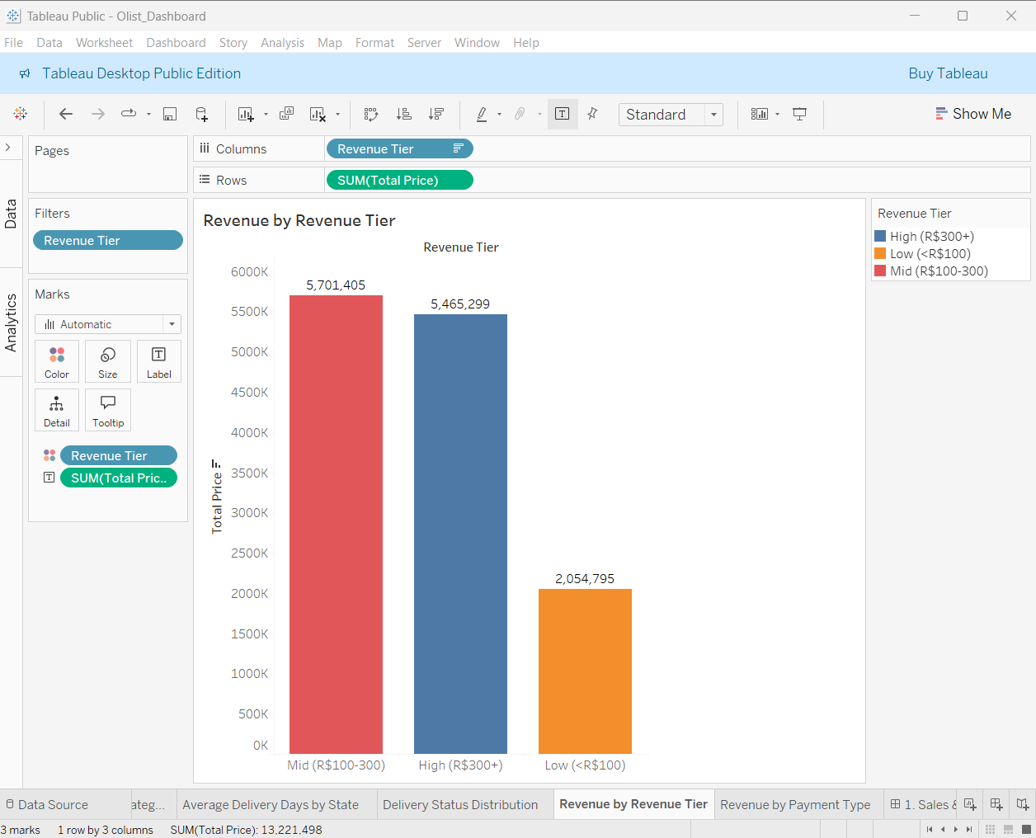
📸 Tableau — Revenue by Revenue Tier

5.2 Tableau Dashboard 1: Sales & Revenue Overview
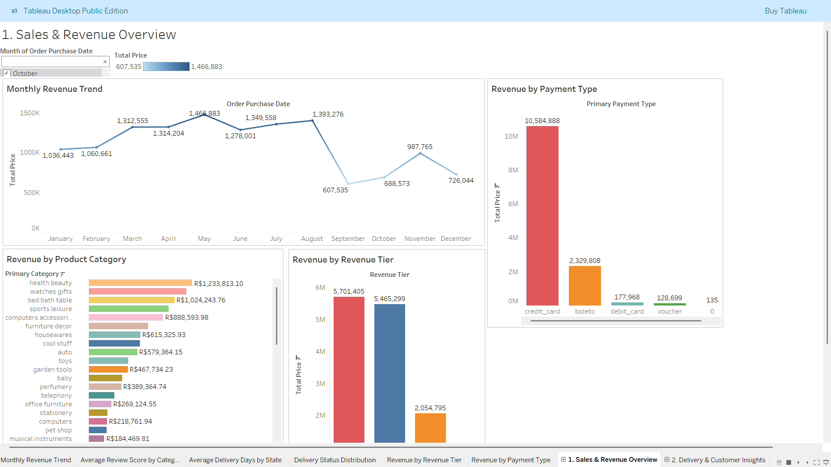
📸 Tableau Dashboard 1 — Sales & Revenue Overview
5.3 Tableau Dashboard 2: Delivery & Customer Insights
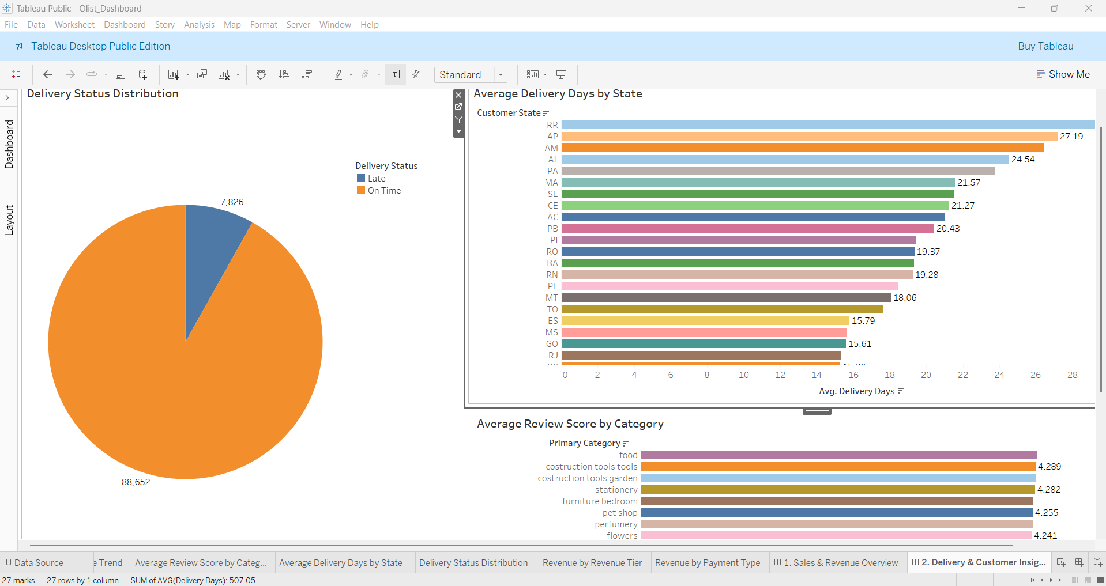
📸 Tableau Dashboard 2 — Delivery & Customer Insights

6. Key Findings from BI Dashboards
São Paulo dominates revenue at 38.28%. Faster delivery is strongly associated with higher review scores (4.42★ vs 3.12★). Credit card = 78.3% of payment value.
7. Deliverables
File | Description
Olist_Sales_Dashboard.pbix | Power BI dashboard file
Olist_Dashboard.twbx | Tableau workbook with 2 dashboards

